An informal guide to running Spock

Stable Isotope Lab, INSTAAR

Summer 2019

Overview

Spock is a Micromass dual inlet mass spectrometer that measures the stable isotopes of carbon and oxygen in atmospheric CO₂. Spock primarily runs samples from flasks and calibration tanks. Almost all of Spock’s work is connected to the NOAA CMDL Cooperative Air Sampling Network. Air samples are collected worldwide in 2.5 liter flasks and are measured for concentrations of CO₂, CH₄, N₂O, H₂, and various other trace gases at NOAA. Spock is designed to measure the isotopic ratios (45/44 and 46/44) of CO₂ in these samples.

Spock measures three masses:
Mass Species
44 ¹²C¹⁶O¹⁶O (the most abundant)
45 ¹³C¹⁶O¹⁶O (carbon 13 isotope)
46 ¹²C¹⁸O¹⁶O (oxygen 18 isotope)

To measure the stable isotope ratios of CO₂, pure CO₂ must be extracted from the atmospheric sample (Figure 1). This is accomplished cryogenically: a vacuum pulls the air sample through a mass flow controller set at 40 sccm, through a chilled ethanol bath held at -90°C to freeze out water, and into a “triple trap” held at ~-200° C with liquid nitrogen to freeze out carbon dioxide (Figure 2). The other gases, oxygen, nitrogen, etc. are vented away. The triple trap is then heated to –20°C and the sample is released into the sample bellows of the mass spectrometer. The reference bellows is filled with CO₂ from a tank of Niwot Ridge air at the end of every run (therefore, it is isotopically quite similar to our sample gas). Aliquots of sample gas and reference gas are released iteratively into the source, where they are ionized, repelled down the flight tube, and separated by isotopic mass. They are collected in Farraday cups, the current is measured, and then a long sequence of data crunching begins! But first, how do we make Spock run?

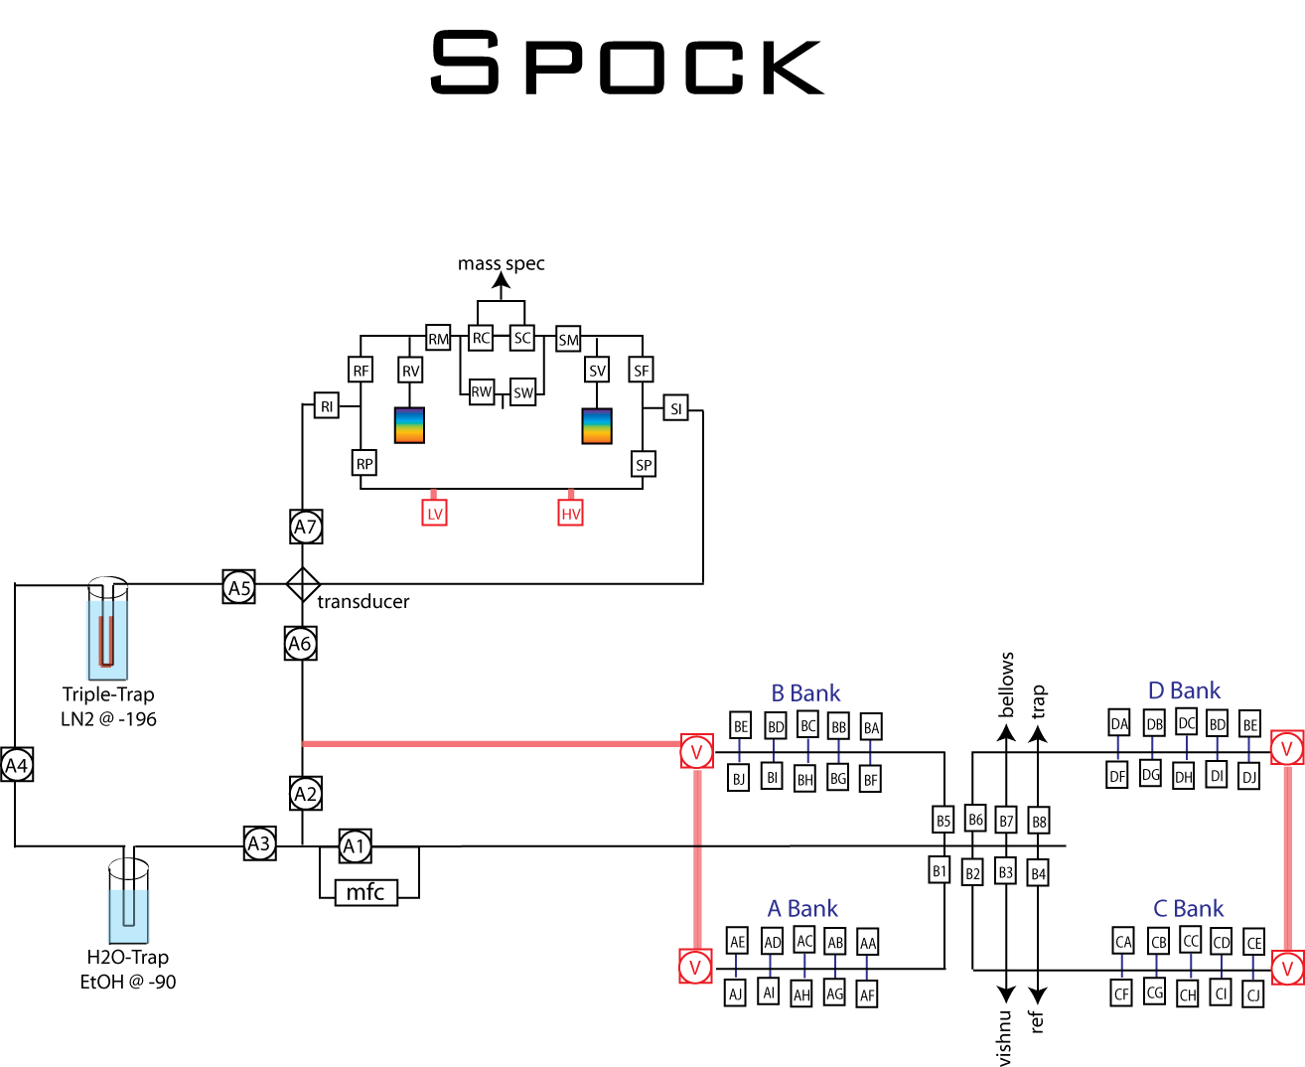

Figure 1. A bird’s eye view of Spock’s extraction system.

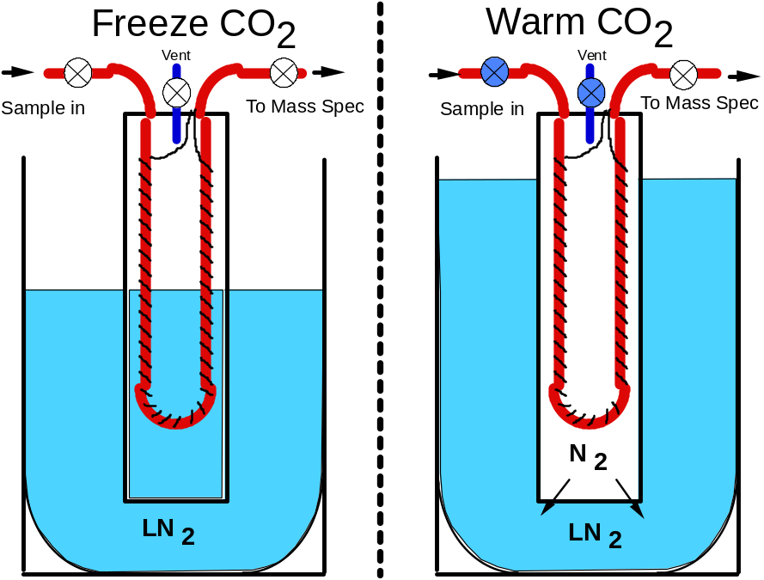

Figure 2. The triple trap. Air is pulled through the tubing, which is within an open-bottomed cylinder and immersed in liquid nitrogen at -200 C. After the extraction, a vent at the top of the cylinder closes, the trap is heated by the wiring wrapped around it, and the vaporized nitrogen displaces the liquid nitrogen. The sample is warmed to -20 C, and is released to the sample bellows.

The Practical Stuff

First things first

1. The run is finished when the message log says “Finished Autorun.”
2. Run a bellows refill before you start the next run (takes about an hour). Go to Program -> Run -> TKRefill2 -> Run
3. When the refill finishes, it leaves the triple trap open to high vacuum. Close MH, A6, and A5.
4. Turn off the liquid nitrogen (switch on the blue control box on the counter between the manifold and the tank).

Computer files
We need to transfer yesterday’s run back to the NOAA database.

1. Close the mass spec software (double click the upper left corner). Yes, you wish to exit.
2. Open the Data folder on the desktop and right click on the SPOCK.TXT file. Click settings -> general -> and change the name of the file to currentrunnumber.TXT (example: 004401.TXT).
3. Left click on the new file and click copy -> A Drive.
4. Wait until the green light on the floppy disk drive turns off, then eject the floppy disk.
5. Shut down the computer. This zeroes the buffer (memory).
6. Inset the floppy disk into the Carbonito drive and copy the file from the floppy disk to the txt file folder on Carbonito.
7. Open Spock CO2 Crunch 1.4 and crunch the current run by pressing “Spock CO2 crunch” and typing in the appropriate run number.
8. Click do not save to all questions until the program asks if you would like to save in the format, then click yes.
9. When the WOW file has been created, check the standard deviation of your reference gas, trap, and other cylinders. Also check the pair agreement between pairs of flasks (should be <.06/.12).
10. Copy performance data from the WOW file and paste it into the performance file and save. If it’s not pasting correctly, paste as values.
11. If you have decided that the run was good, and that you can continue, you can set up the next run.

Cleanup previous the previous run

1. Close all stop-cock valves on the flasks. Make sure that the valves are closed on the manifold graphic on the screen (closed valves are red. Double clicking them toggles them). Carefully take off the flasks by twisting gently as you pull straight up. Make sure all tanks are closed.
2. Flasks that are routed for further analysis will have a sample sheet indicating whether they go to CH₄, VOC, C14, or CH₄H₂. Put these flasks in the appropriate boxes. Flasks with no further analysis go into boxes and onto the cart. Throw away the sample sheet for finished flasks.

Setting up a new run

There are always 4 reference samples in the beginning, middle, and end. Four samples from the “trap” tank follow the middle reference samples. Table 1 shows some sample runs. Do not run more than 28 samples per half (including trap).
Ex. flask run | Example tank run | Example mixed run
4 working ref  20 flasks  4 working ref  4 trap  20 flasks  4 working ref | 4 working ref 4 trap  4 tank A 4 tank A  4 tank B 4 tank B  4 tank C 4 tank C  4 tank D 4 tank D  4 tank E 4 tank E  4 working ref 4 working ref | 4 working ref 4 trap  8 flasks 8 flasks  4 tank A 4 tank A  4 tank B 4 tank B  4 tank C 4 tank C  4 working ref 4 working ref
Table 1. Examples of Spock runs. Each run has 56 samples.

1. Place flasks on the manifold in pairs, indicated by their sequential numbers (and by their sample sheets). Place flask that is listed first on the sample page on the top rack and its pair directly below it.

2. Tanks are connected to the back side of the manifold (also with thinner o-rings and clamps). New regulators should be tested for leaks by flushing 3 times, closing the outside valve first, the main tank valve second, marking the needle position on the pressure regulator, and allowing to sit overnight.

3. The last run number is found in the Log Book and use the next sequential number for the current run. Stamp the sheets with the appropriate run number below the “CO2C13” at the top of the sheet, and then cross the CO2C13 off so that it is clear this analysis has been completed. Sheets that have additional analyses should go onto the manifold (stuck between the legs of one of the pairs). Place the extra sample into a manila envelope run folder, which should also be labeled.

Session builder
This takes the reference tank and flask information and neatly puts it into a run sheet for us.

1. Go to https://om.cmdl.noaa.gov/sb/. This is the Session Builder website that formats runs for us. Choose VG Optima “Spock”. If the login and password do not come up automatically, username is SIL, and password is 20020118.

2. The center scroll bar allows you to choose which type of sample you would like to enter. The options for that type appear on the left, and based on your choice, can be appended onto the window on the right. This will become your sample list for that run. To begin, highlight “working reference” on left. Choose the Spock reference (currently CARR). Its information, including sample port, will appear in the center. If you change your choice in the left window, click “ok” for it to update in the center panel. Once you are satisfied with your choice of working reference, click “append” four times so that the first four samples of the run are of that working reference. Be sure port names are capitalized when entering them into session builder. The current trap tank is HARR.

3. To enter flasks, scroll down to CCGG flask in the middle bar. Enter the flask I.D. (example: 3231-99) in the window, click “search” to find its information in the left window (it will automatically update the center panel). After checking that it is correct, append that information into your sample list. Don’t forget to click ok after each sample so that the information updates the center panel. Append it to your sample list, and check that everything is correct. The ports will automatically begin with AE and update sequentially. You only need to change the flask ports if you are jumping around.

4. If you are running tanks, choose them from either the internal cylinders or external cylinders list. (Internal cylinders have nicknames). Enter the appropriate port manually. For external cylinders, MAKE SURE that the fill date listed for the cylinder corresponds to the tank you are running.

5. Save the session builder as the file name and copy the data that pops up in a new tab. Paste in any txt file and save as the new run number onto Drive A (the floppy disk). Wait for the green light to turn off and then eject.

6. Now transfer the new file from the session builder to Spock. Insert the floppy disk and copy the run to NOAA CO2 by clicking Copy -> Drives -> C drive -> NOAA CO2.

7. Open DI version 2.47 and click OSI2 window. In OSI2, type “make2 runnumber.o1” (example make2 004401.o1) and hit enter. If the computer was successful in making the run, it will tell you so.

Change out the water trap
The water trap is full of water from yesterday’s run. You want to start your run with a dry one.

1. Change the water trap. Make sure that A3 and A4 are closed, gently loosen the Cajons, and pull the trap out. Bring it to the oven named Arwen. Replace it with a dry trap that has been baking overnight.

2. You can tell if the ethanol bath has lots of water in it because hydrated ethanol has a higher viscosity than pure ethanol (it looks slushy). If your ethanol is slushy, dispose of it in the ethanol recycling containers near the walk in freezers. Replace with a new dewer and new EtOH.

Evacuate the Manifold and the Water trap
You need to evacuate anything that was exposed to the atmosphere – the flask manifold, and the water trap.

1. Open the valves that will be used during the run (make sure all flasks and tanks are closed before pumping).

2. Pump on the closed flasks and tank lines until the pressure gauge drops to a static state. Close valves and wait a couple of minutes. If the hold vacuum when reopened, proceed.

3. Evacuate the water trap by opening ML, A2, and A3

Tuning
We tune the machine daily to get the best possible beam – what we see on the screen as a peak. This requires letting reference gas into the mass spec and watching the peak as we make adjustments.

1. Open the reference gas to the mass spec. Change the bellows until the major peak (mass 44) reads 5nA. Allow the beam to stabilize for a minute or so. Run a center scan via control C or by clicking Tests -> Peak Center. This represents the beam that is recorded across a spectrum of accelerating voltages. The center of the scan will be recorded as the “HT” in the upper right dialog box.

2. Using the Raw data option in the Cursor menu, record the “time” (x axis) values at each end of the flat peak. The difference is the peak, and you want to maximize (lengthen) that peak.

3. Occasionally fine tune the peak by adjusting several parameters: HP, ZV, IR, EX, and EV (explained below). You should tune in this order. Run scans of each by going to the “Run Scan Parameter File” and choosing the appropriate scan. You can change the parameters in the Tune Source page (in the Mass Spec menu), or by dragging the red line to the place you think is best. Do a center scan after each change to see its effect, and to record the adjusted HT. Also save the changes in the tuning page as you go under CURRENT. Under the Cursor menu you can also find a zoom in function, a link peaks function (click the two scans that you want to link), as well as the Raw data and a drag functions.

  - HP. Half plates. These are the first plates that the ions go through as they leave the source. Zoom into the peaks of the major and minor beam scans and enter their maxima into the source parameter (or drag the red line there). If the peaks are not coincident, find a compromise between them.

  - Z plate. The z plates narrow the beam in the y plane, whereas the half plates had narrowed the beam in the x plane. You only need to examine the major and minor scans, so un-choose the middle 2 by unclicking them in the “lines” menu. Zoom into the peaks of the major and minor beams, and find the spot that maximizes both of them the best.

  - IR. This is the voltage of the repeller, which repels the ions out of the source and down the flight tube. Find the peak of the major and minor beams in this scan, then go between 1.4 to 1.75 V to the left of it. Currently the IR is approximately 1.7 V below the peak.

  - EX. Find the peak of major and minor beams in the Extraction Voltage scan and go approximately 0.2 V to the left of it.

  - EV. The Electron Voltage scan does not always have a clear peak. Make sure that you are not set in a strange slope or dip.

4. Once your peak is as wide as you can get it (shoot for at least 12 V), save the tuning under these four file names: CURRENT, CO2, AUTORUN, and SILCO2.

5. Record in the notebook the bellows setting, the HT (accelerating voltage), the peak width, and the Ion Guage (also on the screen). Also record the name of the water trap and the bellows position.

6. Go to ID Peak in the Tests menu, and make sure that you are still tuned to mass 45.0. If you are not, change it to 45.0. This is very important to do if the magnet moved or the source was removed.

Preparing Spock for the run

1. Turn on lN2 (flip switch on blue box to “automatic”). Make sure that you have enough lN2 in the tank (half full) for the run. Each tank should last for about 2 runs.

2. Make sure the cryocool is on and the EtOH is chilled to -90 C. Make sure that the thermocouple is in the dewer.

3. Check that the vacuum is at 1*10-3. If you would like, or if you were suspicious of leaks, check again!

4. Double check regulators on tanks to make sure they are working properly and there are no leaks.

5. Analysis: Start/Stop Autorun.
a) Click Analysis -> start Autorun, and select the run that you just made.
b) Respond to prompts for liquid N2, evacuated manifold, etc.
c) When prompted, click YES to ‘open flasks?’ which pops up about five minutes after the run starts. At this time, open flasks or tanks.

Spock is off and running! Watch the data as it appears graphically on the screen. It should be a relatively stable squiggle.

If you need to stop, go to Program:Terminate. You might need to do this several times. This will abort the entire run.
You will then need to go to Analysis:Autorun Batch Edit. Load the run you have just stopped (click on SETUP) and click on Release All. Then go to Analysis:Parameter File Edit. Load the NOAA Sample Parameters and change the start position to 0. Now the run will start at the beginning the next time you start. Also go to the NOAACO2 folder on the desk top and delete the file NOAACO2.txt.

Transferring Spock’s runs to the NOAA database
- Log into your Colorado Microsoft 365 account on Spock’s desktop and access the one drive.
- Click and drag the files you want to transfer from the “out” folder on the Carbonito drive to your one drive.
- On your own computer, log into Pulse secure using your own information and log into FileZilla by typing vortex.cmdl.noaa.gov into “host”, sil into “username”, and 22 into “port”.
- Access your one drive, download the files you want to transfer, and add them to a folder on your computer that you can easily access.
- In FileZilla, locate your folder in the left panel and in the right panel (search bar labeled “Remote site”) type /projects/co2c13/flask/o1/transfer.
- Drag the files from the right (your computer) to the left (NOAA database) to transfer. ☺

